**Marketplace Hackathon**

**DAY 5 - TESTING, ERROR HANDLING, AND BACKEND INTEGRATION REFINEMENT [Bandage]**

1. **Product listing**

**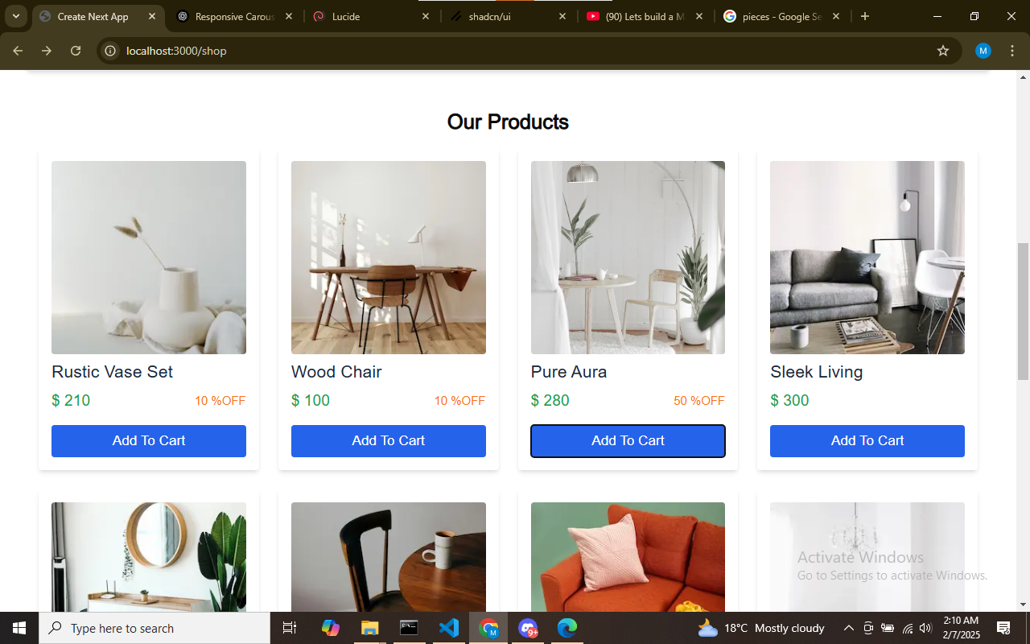  
  
2. Search & Filter category**

**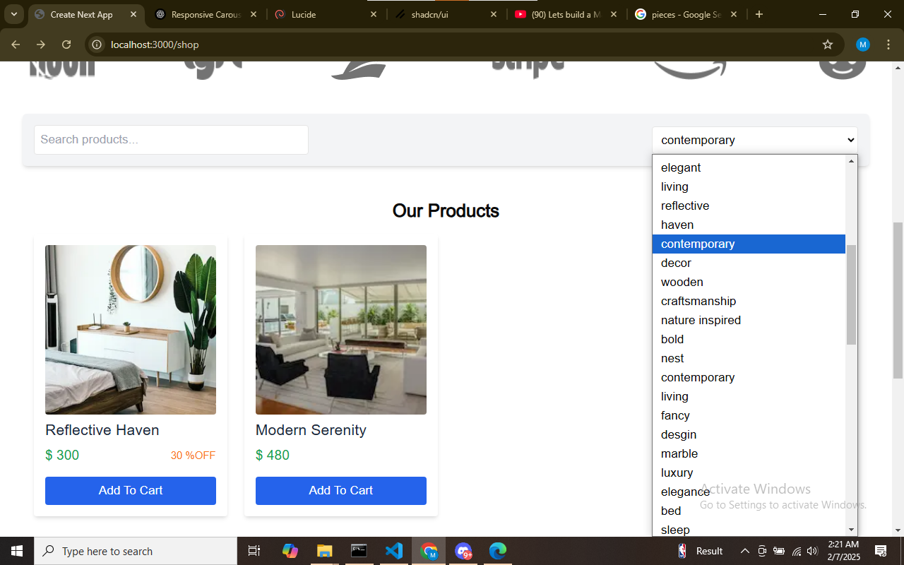  
  
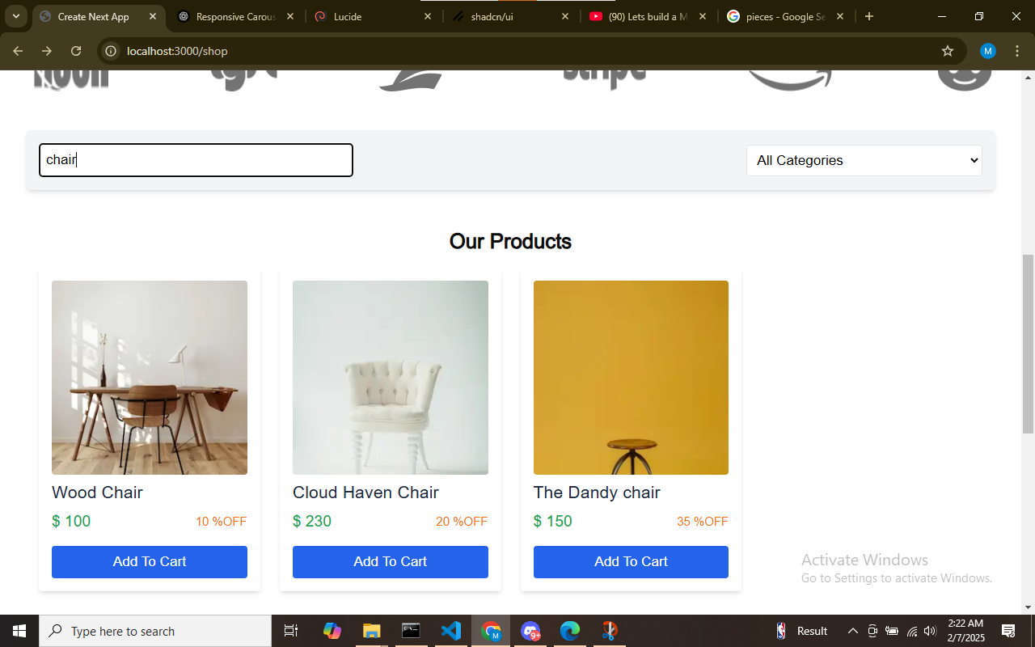**

**3. Cart operations  
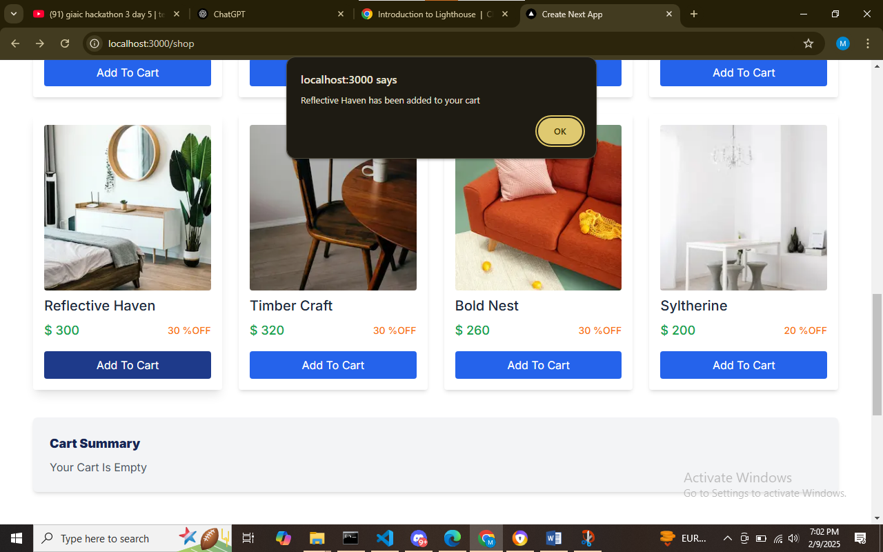**

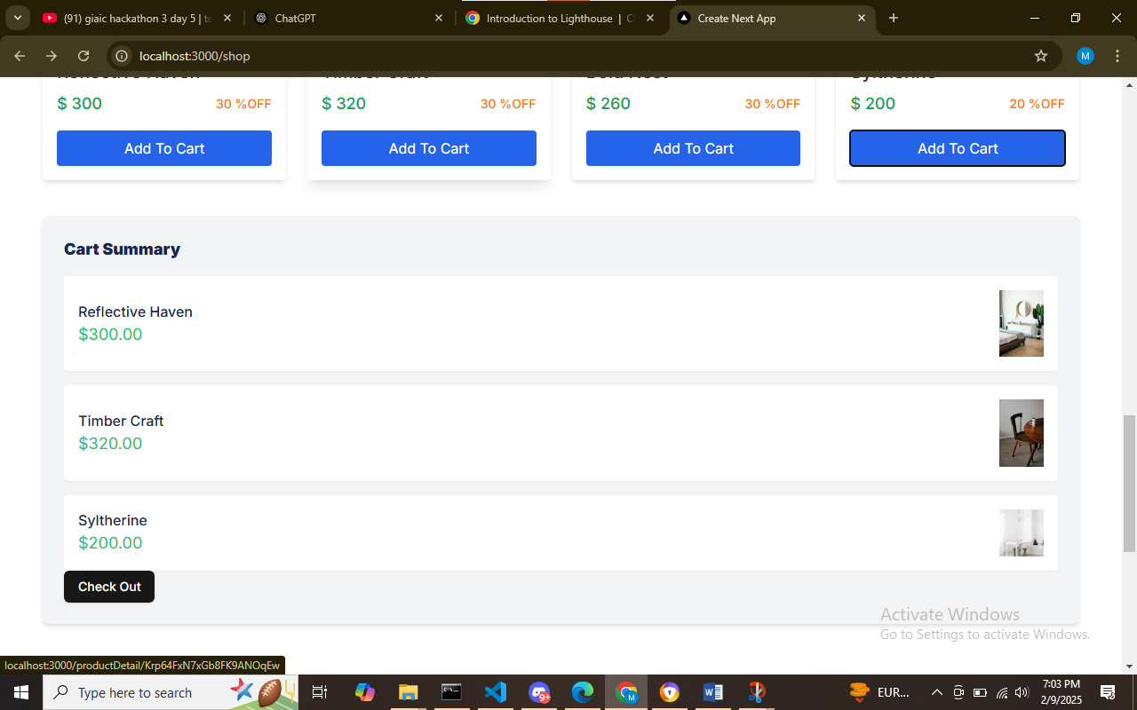

**4.Checkout**

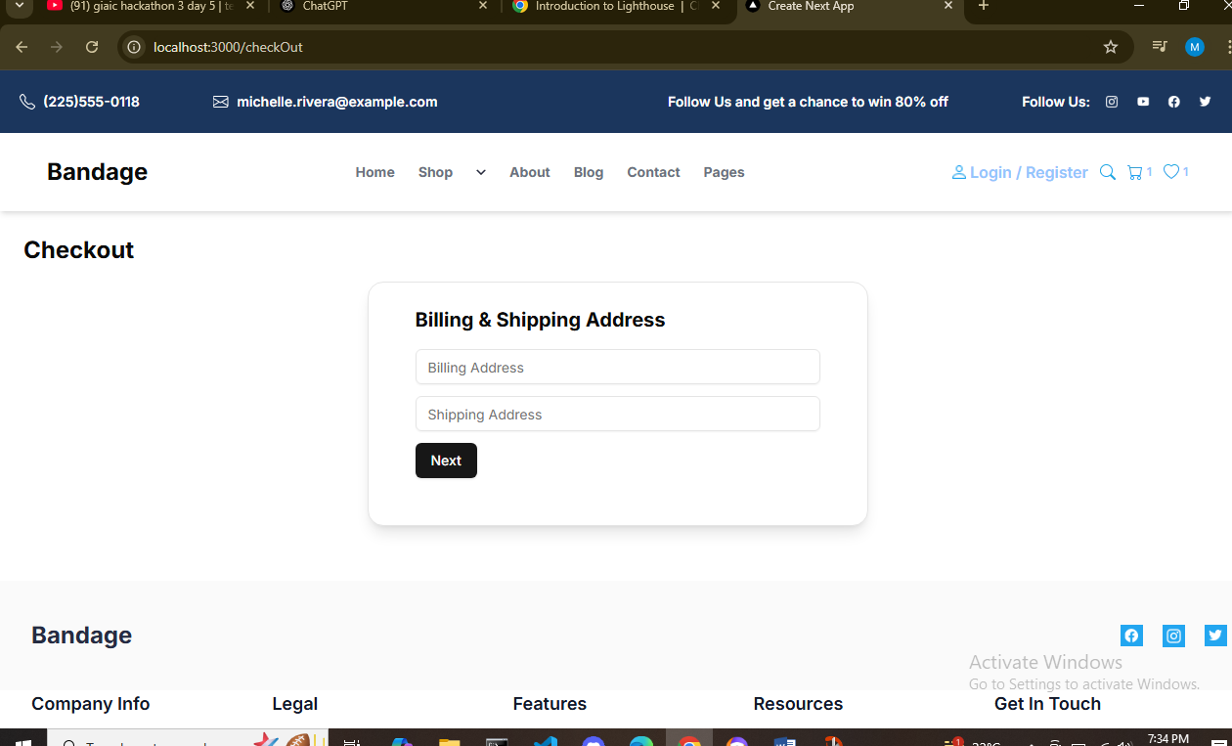

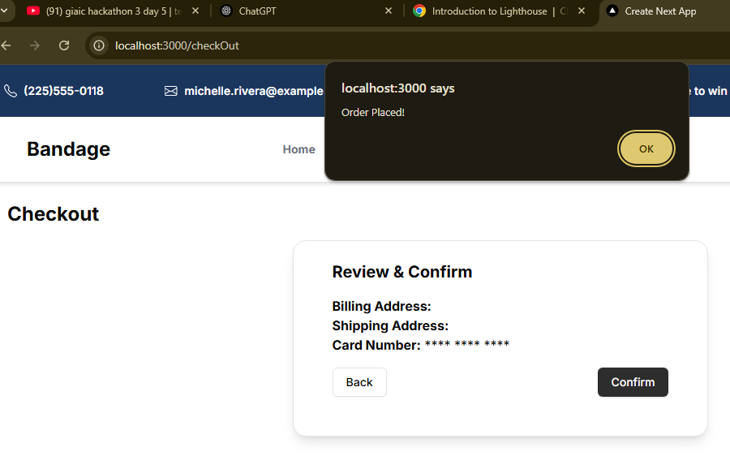

**Dynamic Routing  
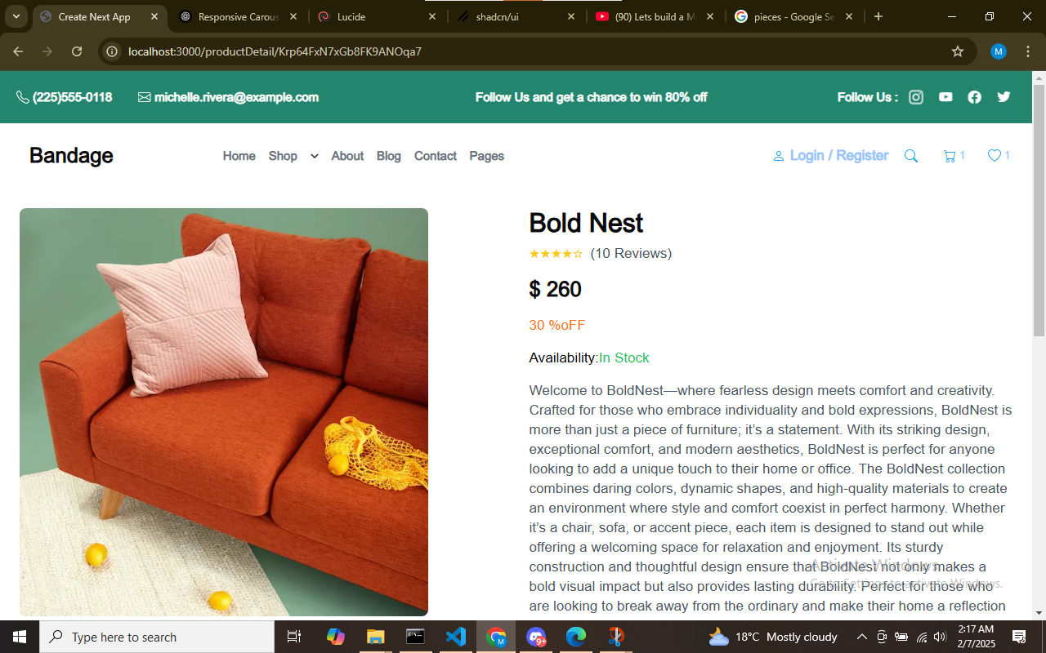  
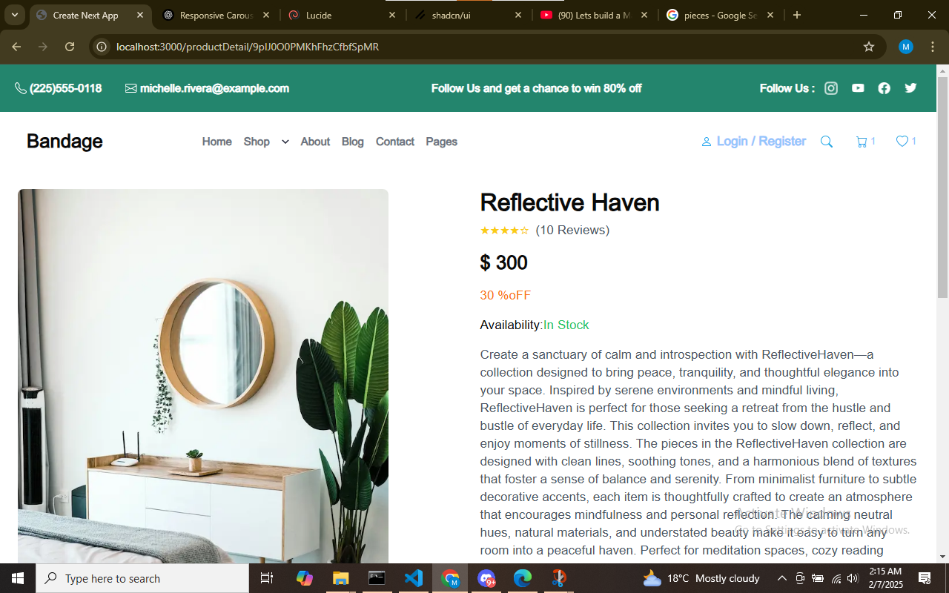**

**Responsive  
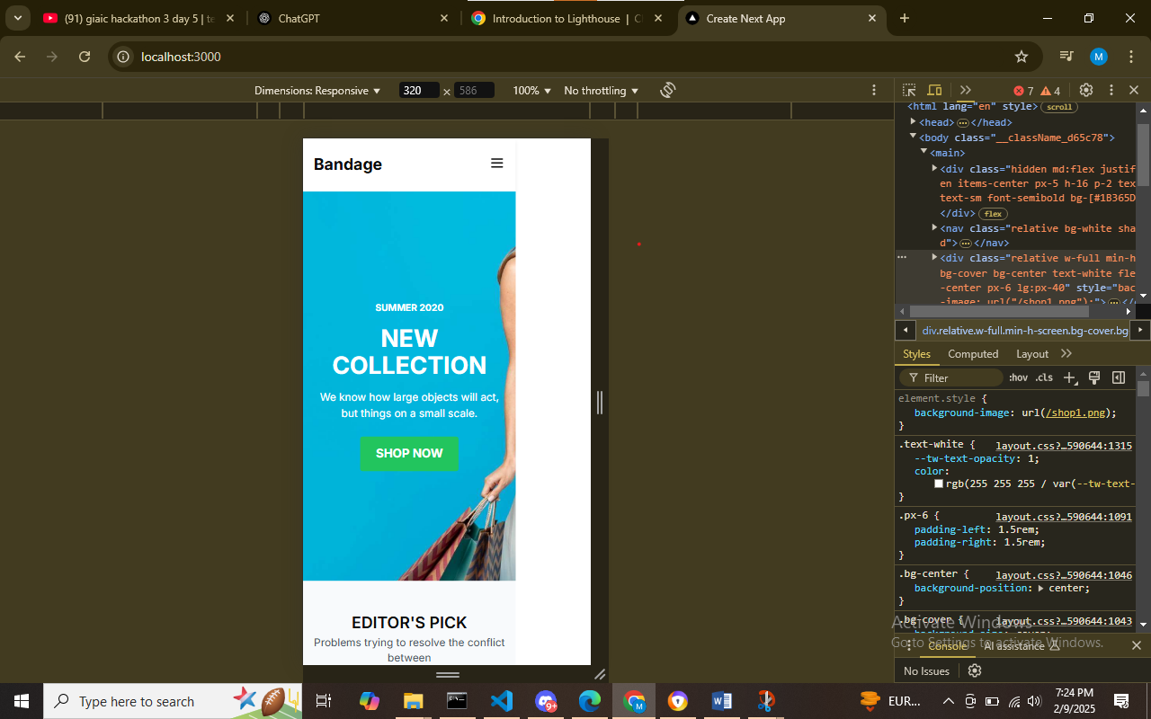**Testing Tool

Thunder client

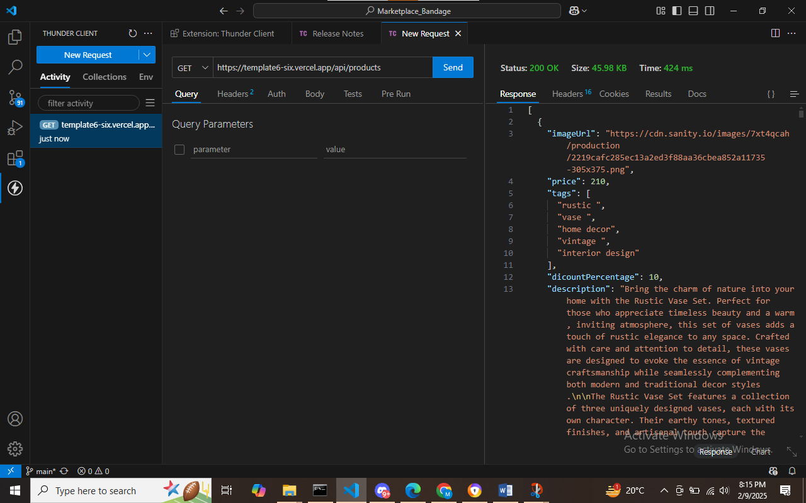

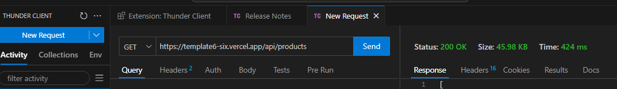

**Performance Optimization:**

**Tool used:Lighthouse**

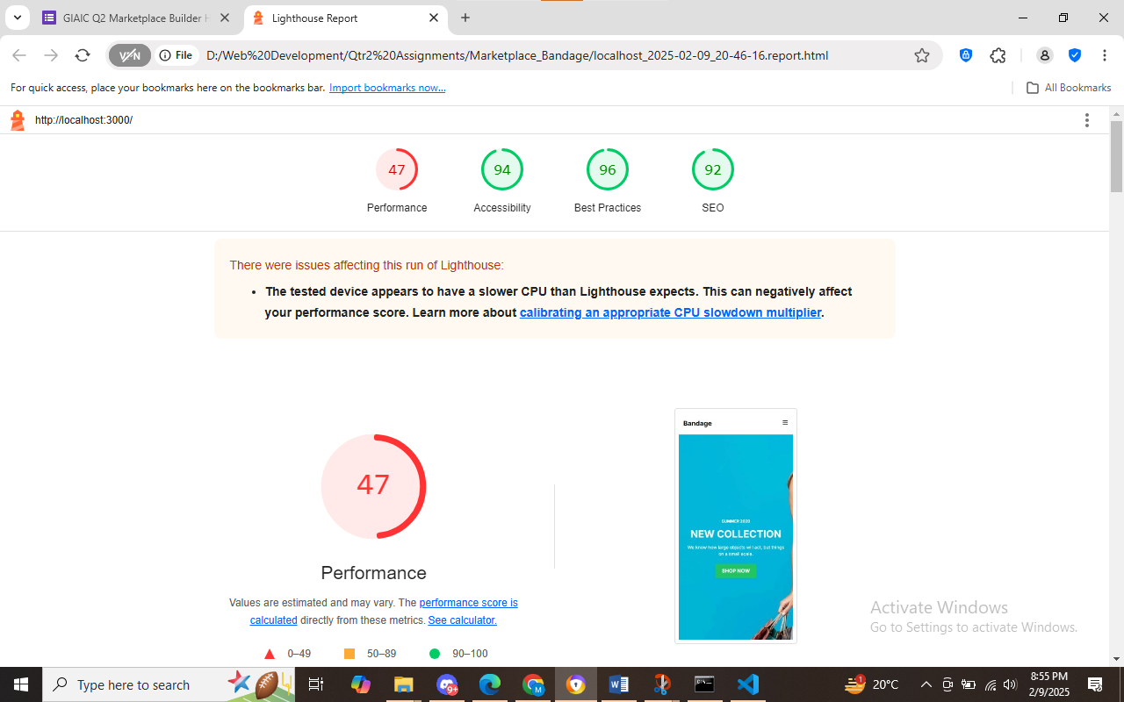

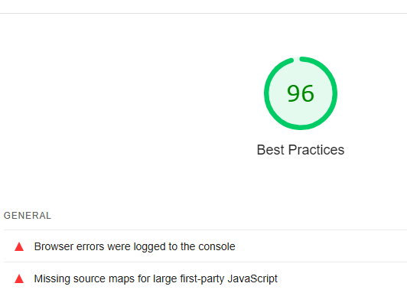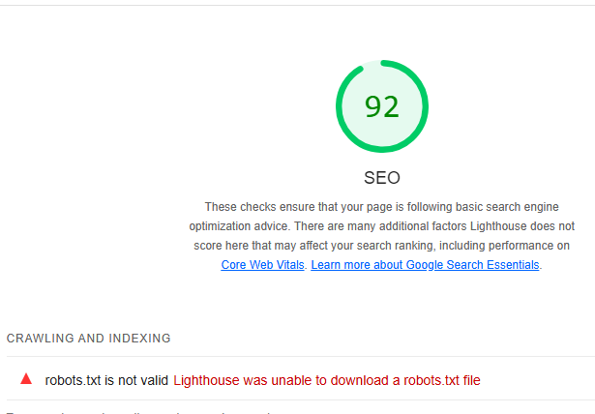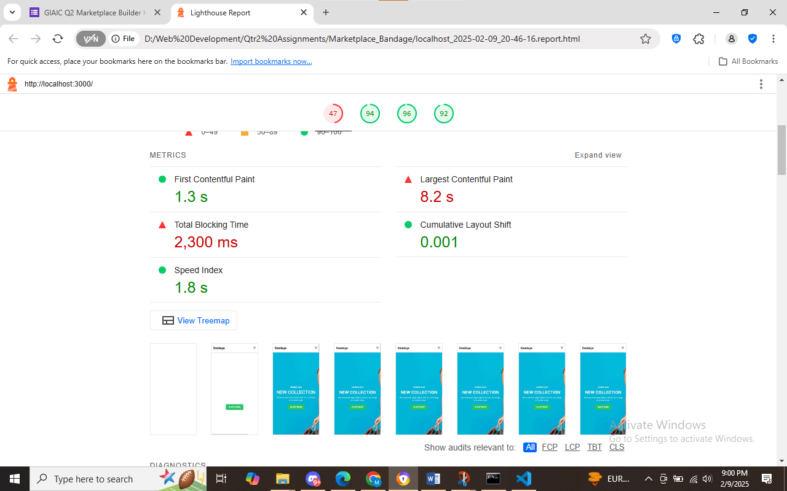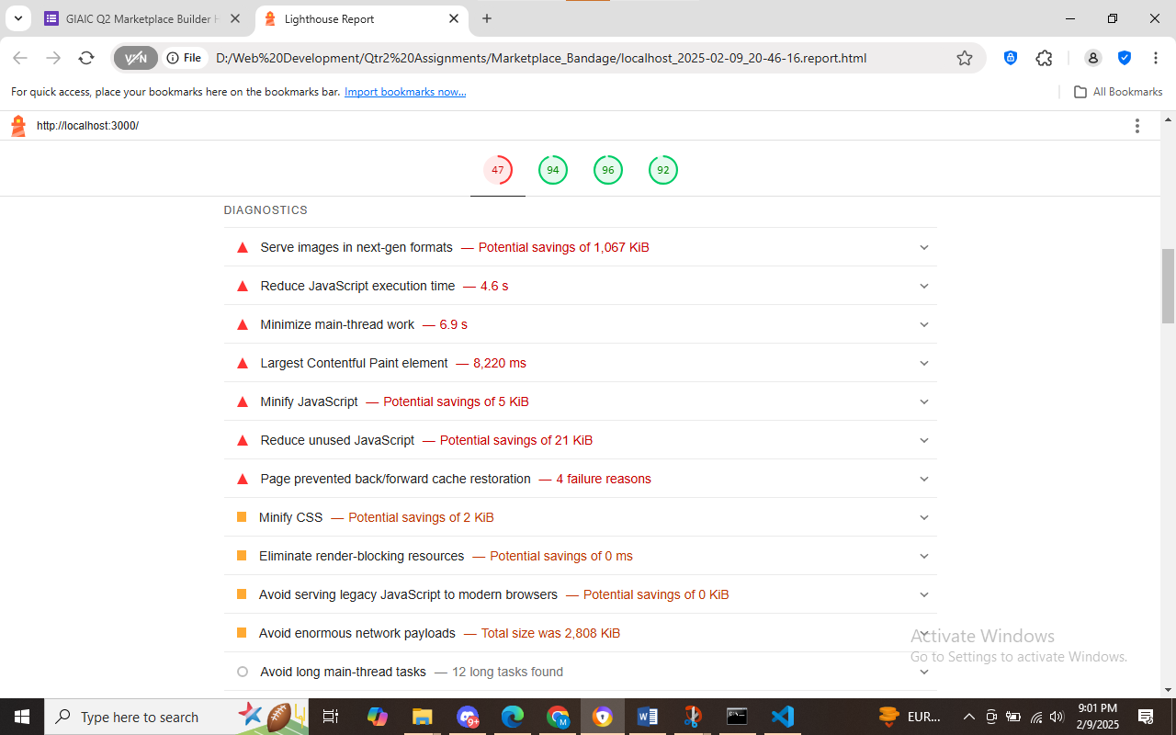

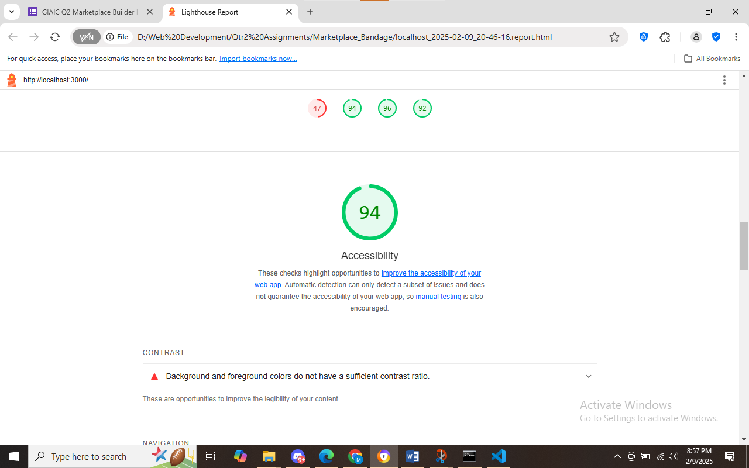

**Developer resources**

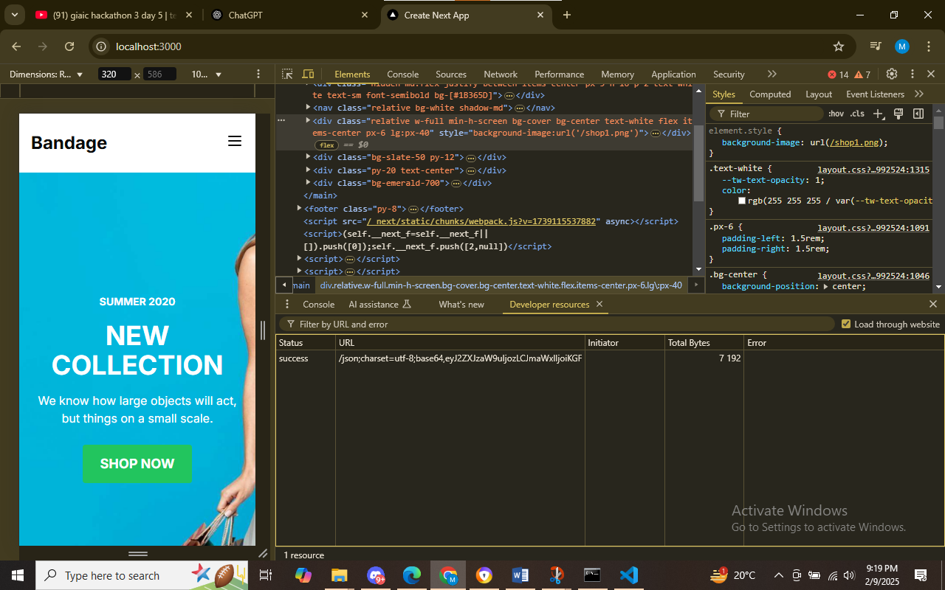

**Performance monitor**

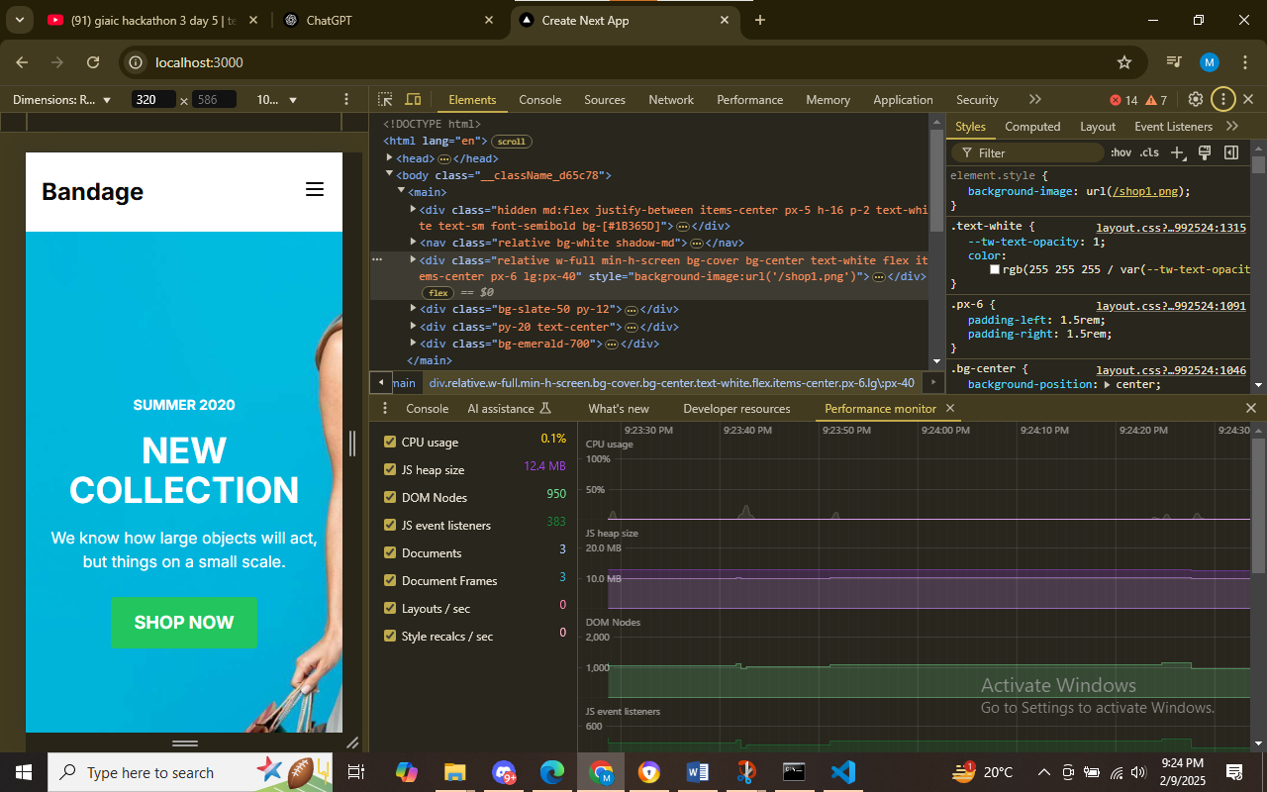

**Issues**

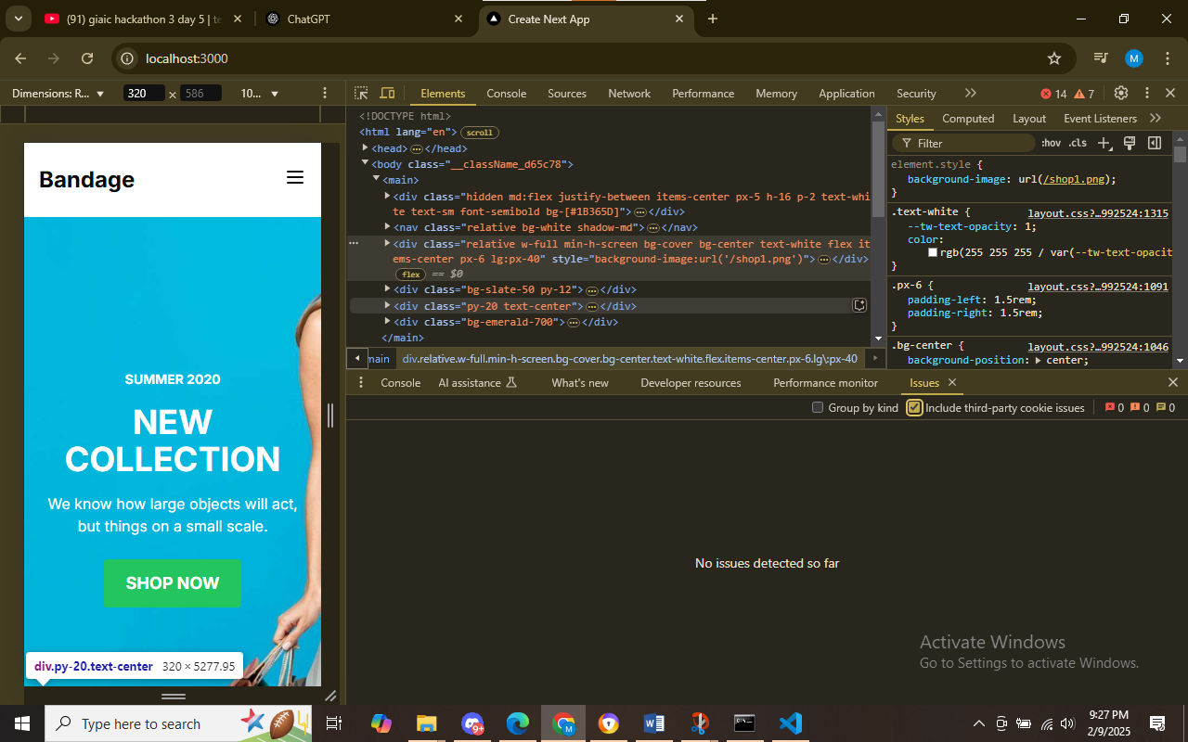

Testing Report(csv format)

|  |  |  |  |  |  |  |  |  |
| --- | --- | --- | --- | --- | --- | --- | --- | --- |
|  |  |  |  |  |  |  |  |  |  |
|  |  |  |  |  |  |  |  |  |  |
|  |  |  |  |  |  |  |  |  |  |
|  |  |  |  |  |  |  |  |  |  |

**Test Case ID,Test Case Description,Test Steps,Expected Result,Actual Result,Status,Severity Level,Assigned To,Remarks**

**TC001,Validate product listing,Open product page > Verify products,Products displayed correctly,Products displayed correctly,Passed,Low,-,No issues found**

**TC002,Verify product details,Open product page > Click on product > Verify details,Product details displayed correctly,Product details displayed correctly,Passed,Medium,-,Works as expected**

**TC003,Check add to cart functionality,Add product to cart > Verify cart contents,Cart updates with added product,Cart updates as expected,Passed,High,-,Feature working fine**

**TC004,Ensure responsiveness,Resize browser window > Check layout,Layout adjusts properly to screen size,Responsive layout working as intended,Passed,Medium,-,Test successful**

**TC005,Test API error handling,Disconnect API > Refresh page,Show fallback UI with error message,Error message shown,Passed,Medium,-,Handled gracefully**

|  |  |  |  |  |  |  |  |  |  |
| --- | --- | --- | --- | --- | --- | --- | --- | --- | --- |
|  |  |  |  |  |  |  |  |  |  |